COMMUNICATION PROTOCOLS

I2C protocol:

1. Supports multiple master multiple slave, up to 1024 devices with 8 bit addressing.
2. Uses serial data(SDA) and serial clock (SCL) lines for communication.
3. I2c is open drain and therefore requires pull-up resistors on these lines.
4. Resistor values decide the speed of communication.
5. Uses device address allocation and internal register allocation to address devices.
6. Use of acknowledge bit ensures correct timing and feedback to weather data has been sent and received relaiably

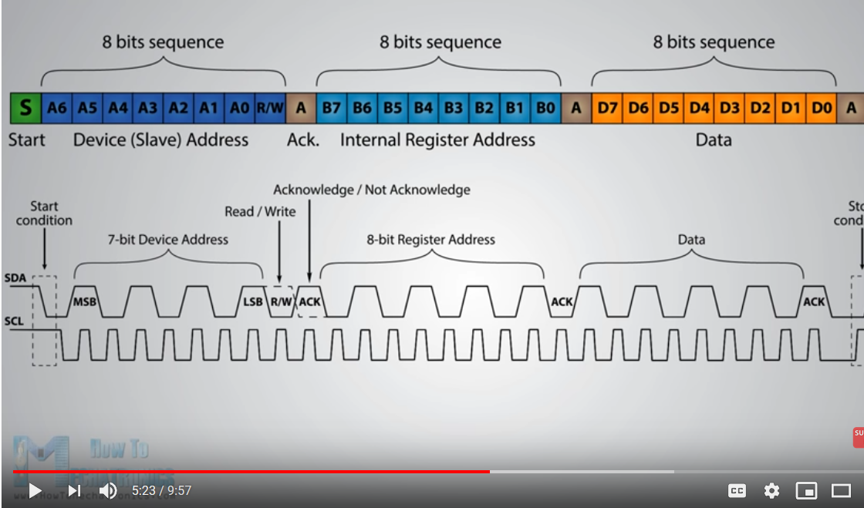

The MSSP module has six registers for I2C operation.

They are the:

• SSP Control Register (SSPCON) >> mode configuration

• SSP Control Register2 (SSPCON2)

• SSP Status Register (SSPSTAT)

• Serial Receive/Transmit Buffer (SSPBUF)

• SSP Shift Register (SSPSR) - Not directly

accessible

• SSP Address Register (SSPADD)\

Note: Before selecting any I2C mode, the SCL and SDA pins

must be programmed to inputs by setting the appropriate

TRIS bits.